EDWARD PALIN 1865 - 2015

150th ANNIVERSARY CELEBRATION
held in St. Mary’s Church, Linton
on Saturday, 19th December 2015.

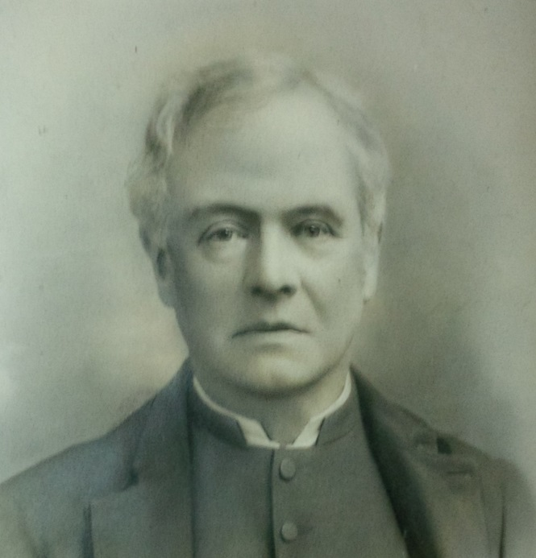

ORDER OF SERVICE

On this day 150 years ago The Reverend Edward Palin was inducted as Vicar of Linton.

We are here to commemorate this auspicious day, to salute the memory of Linton’s most influential son and to give thanks for the astonishing legacy he left behind following his 38 years as our Vicar.

We will now light a candle in his memory.

What was Linton like before Edward Palin arrived?

LINTON IN 1865
The parish was an agricultural backwater, far from the beaten track.

The big landowner and local benefactor was Lord Ashburton, Tory MP of Barings Bank fame, who owned the Eccleswall and Burton estates.

The names of the many tenanted farms you will still recognise
today: Revells, Pithouse, Pinford, Woodend, Fordings, Darnells.
Two-thirds of the area was cultivated on a wheat-turnips-barley-
clover rotation.

The parish population was around 950.

Whilst gentlemen farmers had done well, many others with no schooling available were illiterate and poor. Those who stayed, were employed on the land where wages were some of the lowest in the country. The threat of the Newent Poor House was never far away. Infant mortality was high. Average life expectancy for a man at this time was just under 40.

The local housing stock was in poor condition and both the church and vicarage had seen better days. Linton church sat in an island of unmaintained roads which became impassable after heavy rain.

The Linton that greeted Edward Palin in 1865 was far from Arcadia for the vast majority of his parishioners.

WHO WAS EDWARD PALIN?
Edward Palin was born in Islington in 1825, the son of a storehouse clerk. Although from a humble background, he was academically gifted. He excelled at school before going to Oxford University to read classical history and philosophy at St John’s College.

Edward gained First Class Honours and his MA. He later studied theology and was awarded a Bachelor of Divinity.

Subsequently, he was ordained a priest becoming the curate of St John the Baptist’s Church in SUMMERTOWN , then a new Oxford suburb. A life as a don beckoned.

St John’s College was to be Edward’s home for 22 years where a strict celibacy rule applied for all senior fellows.

Edward’s life changed in the Summer of 1861 on holiday near Lake Lucerne. He literally bumped into the young Brita Gallagher and her American guardian, Caroline Watson. All three are, of course buried in Linton churchyard.

Further to their chance meeting in the Alps, Brita and Caroline visited Oxford. We can only speculate how the relationship developed between Edward and Brita although Edward’s diary indicates he was attracted from the outset. Any liaison whatever was contrary to the strict college rules.

The Reverend Thomas Chandler Curties, vicar of Linton, died in June 1865 after a long illness. The living, including 68 acres of glebe and a gross annual income of £675, was controlled by the St John’s College council. Edward grasped this opportunity for a new life.

At the age of 40, although tipped by many as the next President of College, he opted to leave his city of dreaming spires and cosseted college environment for the rural parish of Linton. As vicar he would, of course, be free to marry Brita.

First, however, he needed a new home………. as the existing vicarage was condemned.

THE NEW VICARAGE
Edward Palin approached the Gothic revivalist architect William Wilkinson to design a brand new vicarage in the ‘North Oxford-style’. The existing dwelling was demolished and a 40 year mortgage arranged through Queen Anne’s Bounty to cover most of the building costs.

Architecturally, the vicarage - now the Old Vicarage- remains the most outstanding building in Linton.

With the vicarage complete, the couple married in Paris in 1867 some 18 months after Edward’s appointment as vicar of Linton. Edward was 42 and his bride 23. There would be seven children. Three boys (Edward, Richard and Henry) and four girls (Brita, Mary, Edith, and Eleanor). All were born in the vicarage. Henry, always known to the family as Harry, was tragically killed at the battle of the Somme.

LINTON SCHOOL
The 1870 Education Act was the first attempt in England to give every child an education. Edward Palin lost no time in planning a new church school in the centre of the village to be built largely from public subscription.

With the consent of St John’s College, he was able to designate a piece of glebe land adjoining the churchyard ‘for the education of children and adults, or children only, of the labouring, manufacturing and other poorer classes in the parish’.

The school opened in May 1872 with 52 pupils. A decade later, with pupil numbers rising to over 100, a new classroom was built specifically for the infants and entirely at the ‘vicar’s expense’. Brita Palin taught sewing and needlework.

Sadly, a rapid fall in school attendance followed the Great War. The school would struggle for many decades before finally closing in the Spring of 1958. The old school building is now, of course, Linton Village Hall and it continues to serve the local community.

LINTON CHURCH
The Ross Gazette described Linton Church in the early 1870s as follows:
“The church, which is of admirable proportions ,…… was in a sad state of dilapidation and decay. The ground around naturally made the interior of the building uncomfortable, being much above the floor level, damp and disagreeable: the roof was so much decayed as to have become dangerous: the high back pews were very ill adapted: the whole fabric plastered, patched, whitewashed internally and externally, all of which disadvantages rendered it totally unfit for divine service.”

In rectifying these problems, the church of today emerged from the extensive renovations instigated by the Reverend Palin.

These focused on removing the lath and plaster ceilings and throwing open the beautiful roof space. Most timbers were cleaned but some were replaced. The whole of the stonework both inside and out, which was previously heavily coated in plaster and whitewash, was laid bare and re-pointed where necessary. Some new windows replaced old but all in the same original style.

The reredos in Caen stone was a present from Brita Palin. A Hereford craftsman, Mr Merrick, carved the stalls of the chancel, chancel screen, altar rail, pulpit, prayer desk and the lectern all in oak.

For the congregation, the seating in the nave was replaced by new pitch pine pews on a raised platform. A handsome pitch pine screen was also erected dividing the vestry from the north aisle. A new font made from Painswick stone was also fixed in the western tower.

The choir originally sat beneath the tower at the far west end of the church and they were accompanied by a large barrel organ. However, a new organ was built in 1888 by Mr Eustace Ingram of Hereford at Edward Palin’s expense.

LINTON’S WATER SUPPLY
In Linton, water from a tap is a very modern experience! Early in his appointment as Vicar, Edward Palin tested the quality of the water in the Linton area. In particular, he had identified a spring feeding into the Rudhall Brook some 200 metres below the site of his new vicarage. This proved suitable for domestic use.

Many years later, a hydraulic ram pump was installed to pump the water from the spring up to the vicarage at the rate of a gallon per minute. The overflow from a tank was then piped to a fountain adjoining the road for universal use. An exception was washing days at the vicarage! The construction costs were paid exclusively by the Palins.

Central Linton received this new water supply in September 1880. The fountain, with its metal lion’s head can, of course, be found in the garden wall of ‘Wren’s Nest’ (opposite the village hall). The memorial inscription was added by Brita Palin after her husband’s death.

We should all rejoice that since 1962, with the arrival of mains water, we have been saved the drudgery of collecting our daily drinking water from the nearest well.

CHRIST CHURCH
In his later years, Edward Palin was greatly concerned by the poverty and lack of education that existed in Gorsley. He had established a Penny Bank and set up workers’ evening classes during his time as curate at Summertown. It was, therefore, unsurprising that he should take similar decisive action concerning ‘Heathen’s Heath’ - the name given to Gorsley by many at the time.

Edward generously transferred part of the Linton Parish tithes to establish the new ecclesiastical district of ‘Gorsley with Clifford’s Mesne’. A new Gorsley School Church was built and a chancel added later.

As a Chapel-of-Ease to the new Church of St Peter’s in Clifford’s Mesne, Christ Church was consecrated in July 1893 in the diocese of Gloucester. Appropriately, Edward Palin gave the opening sermon.

IN SUMMARY
The Rev Edward Palin, BD, JP, had been committed to improving the health and education of all of his parishioners. He died at his home aged 77 in November 1903.

He is buried in the grave of his second son, Richard, who had died suddenly aged 18. They are both remembered in the brass memorial plaque on the wall next to the pulpit.
As we look around the village it is clear that even today Linton is very much in debt to this extraordinary man, and his devoted wife Brita, who both lived life to the full.

AND FINALLY:
In conclusion let us offer a prayer of thanksgiving after which a wreath will be laid on his grave for those who would like to follow out there on their way home.

In the words of a well-known hymn

God moves in a mysterious way
His wonders to perform;

And we give thanks, Lord, that when all might have seemed lost to Edward Palin at the time he was forced to leave his successful life at St John’s Oxford, he was sent to a place where he was able to do so much good.

He might well have felt with that same hymn writer in a later verse:

Ye fearful saints, fresh courage take;
The clouds ye so much dread
Are big with mercy and shall break
In blessings on your head.

The bud may have a bitter taste,
But sweet will be the flower.

And these blessings came our way, sweet indeed was that flower.
We thank you, Lord, for our good fortune that Edward Palin came here and was emboldened to do so much good.

We give thanks for him and for his family and for their generosity to our village; mindful of his example may we now in our turn seek to do what we can for the good of our community today - and for everyone who lives here now.

We ask this in the name of the one who guided him throughout his life, Jesus Christ. Amen
oooOOOooo

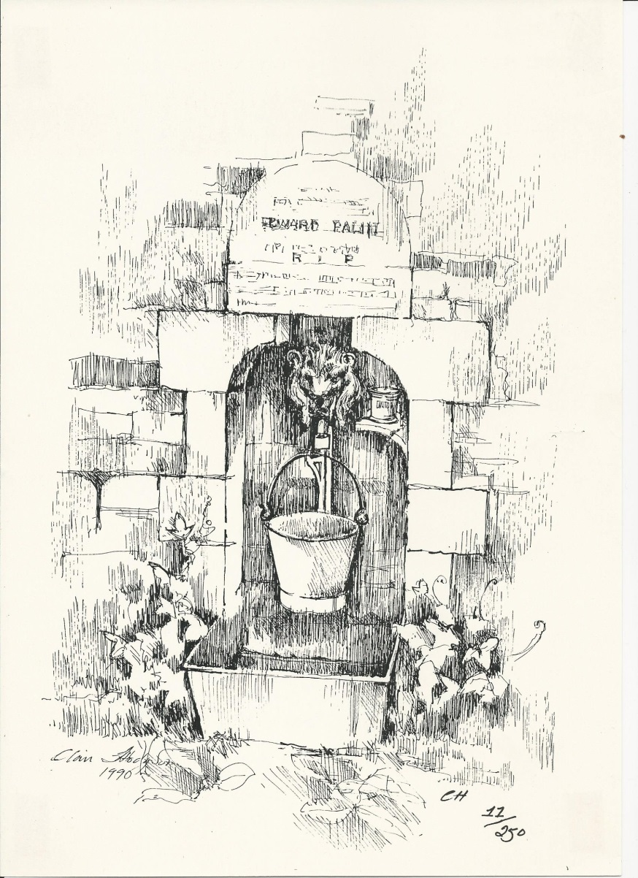

To conclude the evening, a wreath will be laid at the Palin Grave in Linton churchyard.

