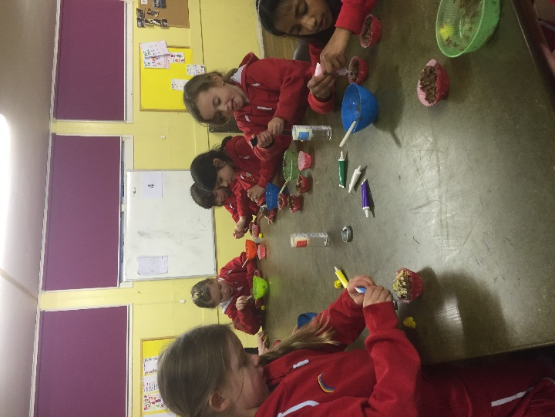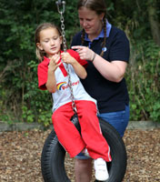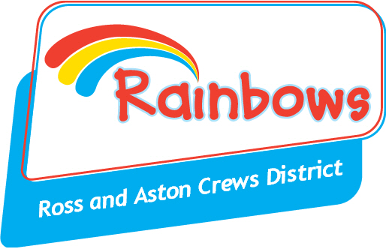

Do you remember the fun you had as a Rainbow or did you miss out but would like to help now?

Vacancies have arisen in units around the local area.

We have friendly and enthusiastic groups of girls aged between 5 and 7 who love to do a wide range of activities from crafts and games through to exploring outside.

You don't need any particular experience to run Rainbows, just enthusiasm and commitment. You will be fully trained and supported by our District Team. Units meet on various weekday evenings.

If you would like to know more please email Jenny Steel - [jennysteel50@hotmail.com](mailto:jennysteel50@hotmail.com) or visit [www.girlguiding.org.uk](http://www.girlguiding.org.uk) to register your interest.

Volunteer

Vacancy