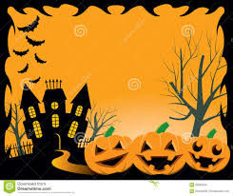

**Come Join our ReVOLTing Gang**

**For a**

**Spooky Halloween Lunch**

**At**

**The Village Hall**

**Linton**

**On**

**Saturday 31st October**

**At**

**12.30**

**Tickets £5 Adult & £2.50 Child**

**Available from The Post Office, Linton**

**The Alma, Linton**

***www.lintonvillage.com***